

Choosing and using indicators

# WHAT & why

**What are indicators and why are they important in a national ecosystem assessment?**

Indicators are information about the characteristics and trends of biodiversity, ecosystem services, and related social systems, making it possible for policymakers to understand the condition, trends and rate of change in biodiversity, ecosystem services and human interactions with the environment.

Indicators are used in ecosystem assessments as both analytical and communication tools to provide quantitative and qualitative evidence and answers to the policy questions that are addressed by the assessment.

For example, a measure of forest cover over time could be used as an indicator to help understand multiple aspects of forests, such as rates of deforestation, or afforestation, or carbon sequestration, or the status of forest-dependent biodiversity, etc… The development of indicators firstly requires defining the issue or question to be understood. Then, identifying the data to help track it.

Indicators can be presented in many forms. They may be a number value for a point in time, such as the percentages of different land uses in a country on a specific date. Many indicators are presented as a time series of measurements or values, which could be shown in a table or graph. Indicators can also be presented in map form, such as colour-coding a map of areas within a country according to the indicator value for each area. Also, indigenous peoples and local communities may have community-based monitoring systems and indicators often used as tools to manage biodiversity and ecosystem services and to document their resources. For instance, these indicators can be used to identify and assess the status of cultural keystone species.

In a national ecosystem assessment, it is recommended to choose and use indicators as tools to help answer the key policy questions, which are generally identified at the *scoping* stage. It is recommended that the definition of the key questions (and therefore the choice and use of indicators) is guided by a conceptual framework for the assessment (Figure 1) and broad consultation with relevant stakeholders. The IPBES conceptual framework can be a starting point for the development of an assessment-specific framework.

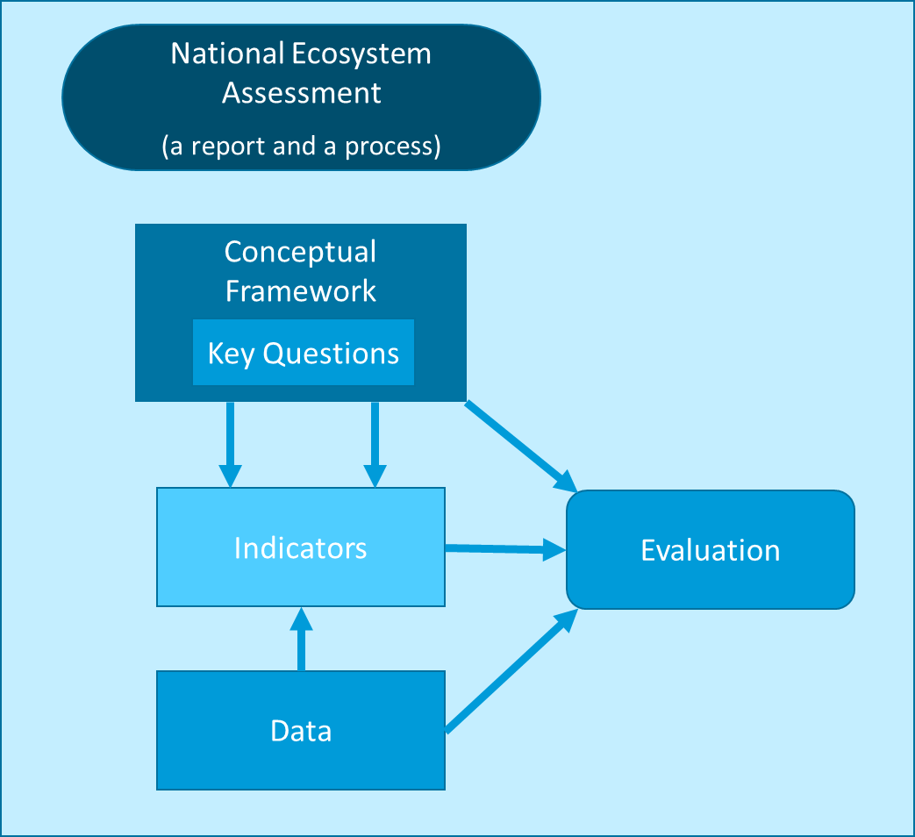Note that indicators require a data source. The data is analysed, summarised, and communicated as an indicator for the question or topic of concern. Sometimes the data or a measurement can simply be used in its original form, when it is a direct measurement of the subject of interest, such as statistics about the area of forest to report on forest cover.

*Figure 1. A schematic diagram of how the choice and use of indicators in the expert evaluation stage of an national ecosystem assessment can be guided by its key policy questions and conceptual framework, as well as the availability of suitable data.*

# *When?*

When and where in the process should indicators be identified?

The choice of indicators and their use will principally be made during the *expert evaluation* stage. While some indicators may be identified as part of the assessment’s Annotated Outline, they will often be selected and used in the zero-order draft of the assessment report. The results of indicators presented in tables, graphs and spatially (maps) will form a central part of the knowledge-base brought together by the assessment. Thus, indicators will be used and refined in all of the review stages of the chapters. Indicators will also be used in the stage *‘Use of assessment findings’* as communication tools to help summarise and explain the assessment’s findings. Finally, the assessment’s indicators can strengthen a country’s system for monitoring and evaluation to track progress around the conservation and sustainable use of biodiversity and ecosystem services.

# How?

How to choose indicators for the assessment

Below are some suggested steps for choosing indicators during a national ecosystem assessment process:

1. Agree on the key policy questions that the assessment will focus on, potentially through a broad process of consultation with multiple stakeholders.

*Example: a national ecosystem assessment may include a policy question on nature’s contributions to health and wellbeing.*

Determine the information and evaluation needs of the assessment, i.e. what do you need to know and measure to help answer the policy questions.

*Example: if a policy question focused on nature’s contributions to health and wellbeing, information would be needed on which ecosystem services are contributing to health. Therefore any existing indicators or data sources that help to measure these ecosystem services (e.g. access to safe drinking) could be identified.*

1. Identify and compile relevant knowledge, data, statistics and any existing indicator sets relevant to the key policy questions.

*Example: sources for relevant knowledge, data, statistics and other existing indicator sets can include information and reports produced by relevant government ministries, non-governmental organisations, and academia, as well as indigenous and local knowledge.*

Draft and/or select indicators for the determined information needs.  
*Using the compiled data and knowledge sources, draft and/or select indicators based on the assessment’s information needs. Analyse these indicators using the compiled data sources as evidence for the assessment’s chapters.*

1. Review the selected indicators in collaboration with data providers and knowledge-holders.

*Engage with providers of original data and indicators, including indigenous and local knowledge holders, to help ensure proper use of information for the chosen indicators.*

How to use and present idicators in the assessment

It is recommended to consider the use and presentation of data and indicators in different forms, such as data tables, graphs and maps, as well as quantitative and qualitative indicators. Working with graphic designers can be helpful, especially if they have experience with science communications or have worked with data from multiple knowledge systems. The following examples of graphics and indicators from [Colombia’s National Assessment on Biodivesity and Ecosystem Services](https://natura.org.co/publicaciones/evaluacion-nacional-de-biodiversidad-y-servicios-ecosistemicos-de-colombia/) illustrate different ways to use and present quantitative information and summary messages with the help of indicators.

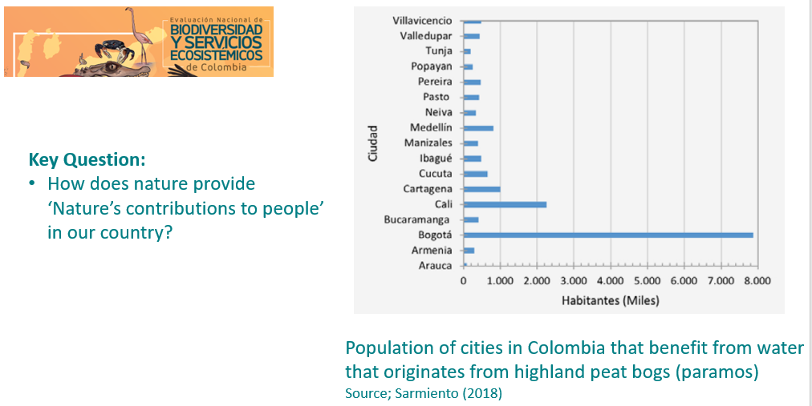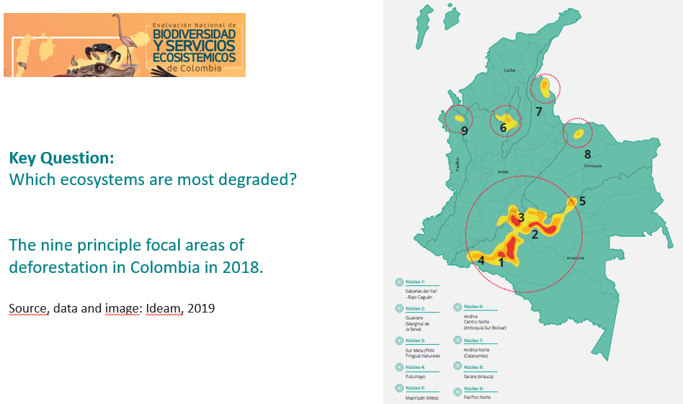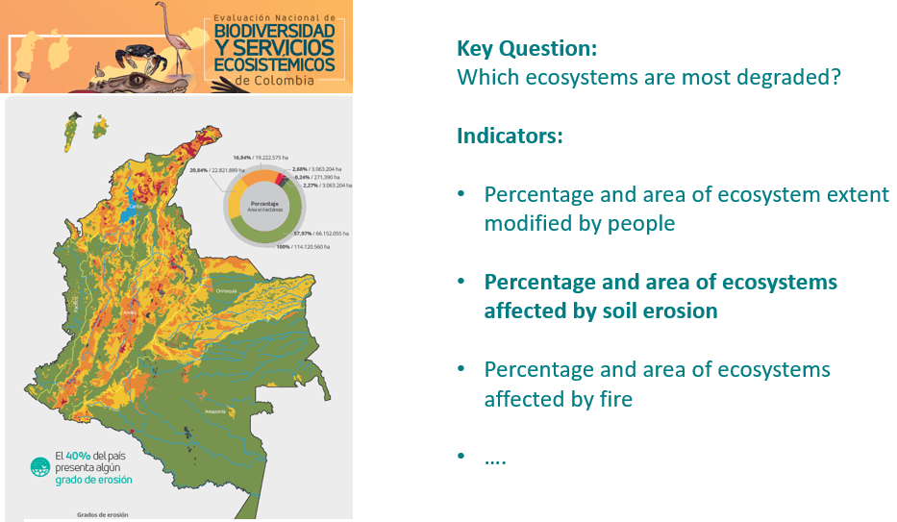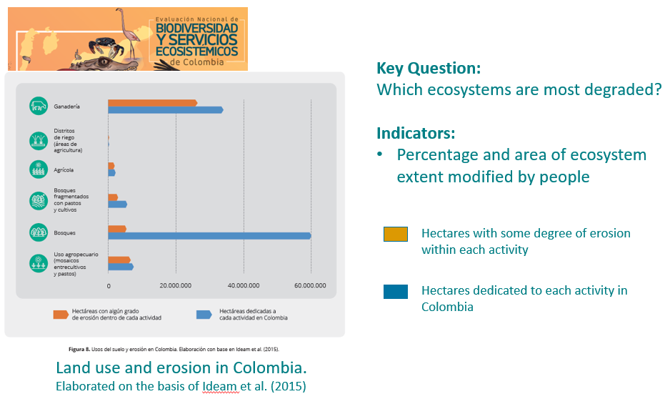Examples of indicators from Colombia’s National Assessment on Biodiversity & Ecosystems (2021)

# Indigenous and local knowledge-based indicators

Indigenous peoples and local communities as local resource users and custodians are the first to experience and detect ecosystem changes and their impacts. Many of them have developed monitoring practices, and indigenous and local knowledge enhances monitoring by enriching knowledge base.

Environmental community-based monitoring systems and indicators are usually based on indigenous and local knowledge, and are informed by biocultural traditional practices and indicators. Community-based monitoring systems can help develop indicators that accurately capture social-ecological linkages and biocultural diversity that are essential for sustainable use of natural resources. For instance, the Maori-based cultural health index can be used to assess the cultural health of freshwater ecosystems. Sometimes, current community-based monitoring systems and indicators combine indigenous and local knowledge and scientific mapping tools, such as participatory 3-D modelling. Community-based indicators can also enhance environmental governance and management monitoring. For example, the Micronesia protected area management effectiveness scored card measures stakeholder engagement, indigenous and local knowledge, and other aspects of effective protected area managemeny at a local level~~.~~

# Who?

Who does this stage relate to?

The selection and use of indicators is conducted by all types of authors of the assessment, with lead authors taking overall responsibility and key decisions. Lead authors should also include inputs from from key knowledge holders and stakeholders, including technical working groups, science-policy-practice platforms, indigenous peoples and local communities, and stakeholders from different governmental and industrial sectors. Communications specialists, including graphic designers, can also work with the assessment’s indicators to effectively present key information in the technical report and the Summary for Policymakers.

# Resources

The Biodiversity Indicators Partnership (BIP)’s website provides information on different types of quantitative and qualitative indicators for biodiversity. The website includes a section on [indicator development](https://www.bipindicators.net/national-indicator-development) as well as guidance documents in the [resources section](https://www.bipindicators.net/resources?filters%5Bcategory%5D=47). Visit:

* Website: Biodiversity Indicators Partnership (BIP): [www.bipindicators.net](http://www.bipindicators.net)
* Guidance: Key knowledge for successful biodiversity indicators:

<https://www.bipindicators.net/resources/national-resources/key-knowledge-for-successful-biodiversity-indicators>

The National Ecosystem Assessment Initiative (NEA Initiative) website hosts a range of resources to support the implementation of ecosystem assessments, including webinars on using indicators in national ecosystem assessments. Visit:

* Webinar: Using indicators in national ecosystem assessments

<https://www.ecosystemassessments.net/resource/webinar-indicators-dec2021/>